**image to gcode** online (only black will be drawn)

<https://www.thuijzer.nl/image2gcode/>



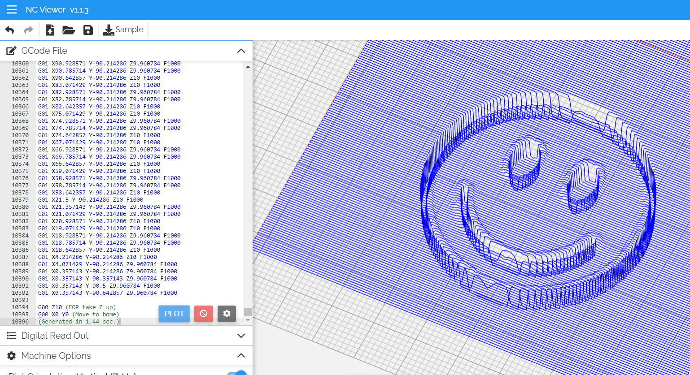

**Images to G-Code**

<https://www.scan2cad.com/blog/cnc/convert-jpg-to-g-code/>

**Generate G code from Image using Inkscape and Python**

<https://blnlabs.com/generate-g-code-from-image-using-inkscape-and-python/>

**G code viewer**

<https://ncviewer.com/>